**Python Flask API Deployment in AWS EC2 Instances**

* First Need to create the AWS EC2 instances , I created the t2.small instances with the as **ubuntu server** with suitable configurations
* After Opening the terminal follow the below steps

First need to update the ubuntu terminal with this command:

**sudo apt update && sudo apt upgrade -y**

First need to navigate to the project directory:

**cd /home/ubuntu/deepface**

Then activate the virtual environment with environment name

**python3.12 -m venv firelot**

**source firelot/bin/activate**

Run the dependency with this command to :

**pip install -r requirements.txt**

Then run the script to be deployed in the server with file name   
 **Python main.py**

If you want to be remove any particular file from the directory use this command:

**Sudo rm -rf main.py**

Command to deploy the particular script in the server to access the API globally use this command:

**nohup python your_script.py > output.log 2>&1 &**

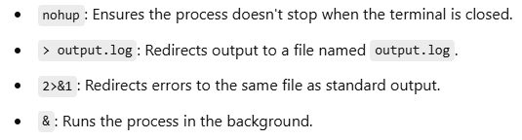



**ps aux | grep your_script.py**

**If your script was started using nohup, you can stop it by following these steps:**

### **1. Find the Process ID (PID)**

To locate the process ID of your running script, use the following command:

**ps aux | grep face1.py**

**This will show something like:**

ubuntu 1769 8.1 25.8 1545752 520484 pts/0 S 09:12 0:02 python face1.py

ubuntu 1772 0.0 0.1 7084 2048 pts/0 S+ 09:12 0:00 grep --color=auto face1.py

Here, the **PID is 1769** (replace with the actual PID from your result).

### **2. Kill the Process**

Once you know the PID, use the kill command to stop the process:

**kill 1769**

If the process does not stop, use kill -9 for a forced termination:

**kill -9 1769**

**3. Make Changes and Redeploy**

After stopping the script, make your necessary changes, and redeploy it using:

**nohup python face1.py > output.log 2>&1 &**

You can confirm the script has restarted by checking the process again:

**ps aux | grep face1.py**